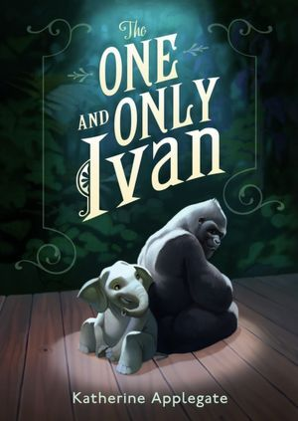
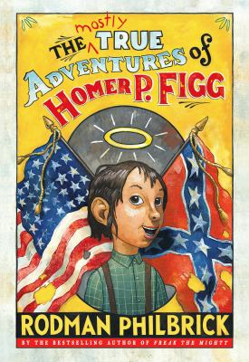
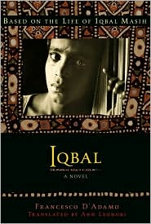
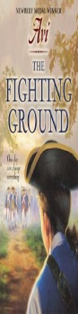
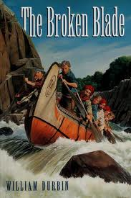
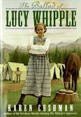
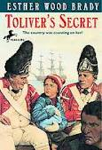

Our Next Book - Iqbal

This year our fifth graders will read at least seven novels as a class (in addition to their own self-selected and literature circle texts). We believe that children need to read good literature and have authentic discussions about what’s being read! The following novels will be used to supplement literacy and social studies instruction. We would love to have additional copies of any of the books we read to help us gain class sets! We will have 13-15 copies to ensure that all students can have their hands on these novels! Thank you for your generosity in advance!

Book List for the 2012-2013 School Year
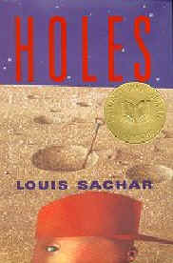
The One and Only Ivan byatharine Applegate
Unit of Study | Title and Author
Our Global Economy | Iqbal by Francesco D’Adamo
North America Colonization | Broken Blade by William Durbin
Revolutionary War | Toliver’s Secret by Ester Wood Brady
Post-Revolution Era | The Fighting Ground by Avi
Westward Expansion | The Ballad of Lucy Whipple by Karen Cushman
Civil and Reconstruction | The Mostly True Adventures of Homer P. Figg by Rodman Philbrick

***Although, we understand some books may be repeats for your children, our hope is to experience them for the first time together. If at all possible, please do not allow your children to read the class novels prior to instruction.***

