Mills Park Elementary School
2013 Science Fair Entry Form
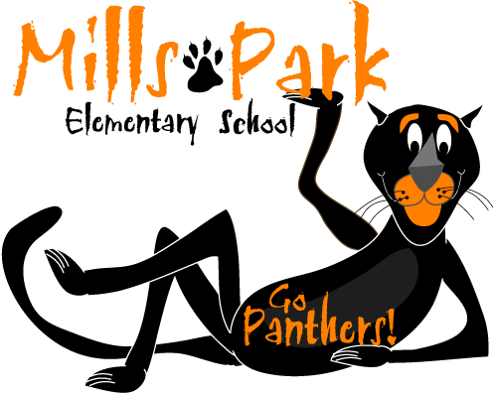
Due: December 20, 2012

Name: _____________________________________________________________________
Grade: ____________________ Teacher: ____________________________________
Partner Name(s): _______________________________________________________
Partner’s Teacher(s):__________________________________________________
Project Title: ____________________________________________________________

Abstract: ________________________________________________________________________________________________________
________________________________________________________________________________________________________
________________________________________________________________________________________________________
________________________________________________________________________________________________________
________________________________________________________________________________________________________
________________________________________________________________________________________________________
________________________________________________________________________________________________________________________________________________________________________________________________________________________________________________________________________________________________________________________________________________________________________________________________________________________________
________________________________________________________________________________________________________
________________________________________________________________________________________________________
Will your project require an electrical outlet? [ ] Yes [ ] No
Will your project involve animals or chemicals? [ ] Yes* [ ] No
*If you checked yes, please be sure to read the rules and regulations on the NC Science Fair website regarding these materials. Prior authorization may be required.

Parent Statement:
I have reviewed the plans for my child’s Science Fair project. I agree to offer support in the form of encouragement, guidance, and help with potentially hazardous items or construction work rather than through actual work on the project or display. I also agree to keep the cost of the materials and equipment within reasonable limits.

Parent Signature: __________________________________________________

